

**Standard Operating Procedures**

**Carl J. Shapiro Simulation and Skills Center**

**Department of Academic Affairs**

**Shapiro Center SC-OG20**

Standard Operating Procedures

**Table of Contents**

Introduction

**Section 1 – General Information**

Beth Israel Deaconess Medical Center Mission Statement

Code of Conduct

Abbreviations

Department Shared Drive

Organizational Chart

SASC Advisory Board

Floor Plan

Decision Making

Required Disclaimers

Conducting Research in the SASC

3D Printing

Video Recording in the SASC

Brand Usage Policy

Contact Information

Hours of Operation

Overtime

**Section 2 – Scheduling**

Calendar

Rolling Schedule

Outreach for Scheduled Courses

Approval for New Courses

Class Prioritization

Class Cancellations

Prioritization of Resources

Outside Learners and Rental Fees

Outside Learners Cancellation Policy

**Section 3 - Equipment**

Simulation Maintenance and Repair

Acquisition of Equipment

Borrowing Task Trainers from the SASC

Equipment Loans/In Situ Use

Inventory

**Section 4 – SASC Operations**

Weekly Huddle

Monthly Staff Meeting

Start Up Process

Shut Down Process

Class Attendance

Embedded Person

Session Evaluations

Audio Visual Systems

Visiting Student Policy

Sustainability in the SASC

Visitor Parking

Guest Wireless Access

Printer Access

**Introduction**

The Carl J. Shapiro Simulation and Skills Center (SASC) is a unit within the Shapiro Institute for Education and Research at Beth Israel Deaconess Medical Center and Harvard Medical School. The SASC is responsible for incorporating simulation-based education and professional development for medical students, residents, and practicing medical professionals.

1. General Information

**Beth Israel Deaconess Medical Center Mission Statement**

*To Provide Extraordinary Care, Where the Patient Comes First, Supported by World Class Education and Research.*

The mission of the Beth Israel Deaconess Medical Center is to serve our patients compassionately and effectively, and to create a healthy future for them and their families. Our mission is supported by our commitment to personalized, excellent care for our patients; a workforce committed to individual accountability, mutual respect and collaboration; and a commitment to maintaining our financial health.

The mission statement of the Carl J. Shapiro Simulation and Skills Center is to train and educate all clinically active healthcare providers, students, and allied health care staff by using the latest and most sophisticated education methods and technology available. In doing so we will advance the field of simulation education and research while supporting both individualized learning methods and promoting interdisciplinary teaching and team training. Thus, we enable all learners to acquire and enhance their skills and knowledge in support of independent lifelong growth

**Code of Conduct**

The SASC utilizes the ethical standards set forth by Beth Israel Deaconess Medical Center to guide professional conduct. The Code of Conduct can be found on the BIDMC website by using the following link: https://www.bidmc.org/-/media/files/beth-israel-org/compliance/codeofconduct19.pdf

**Abbreviations**

**BIDMC** – Beth Israel Deaconess Medical Center

**CME** **–** Continuing Medical Education

**HMFP** – Harvard Medical Faculty Physicians

**HMS –** Harvard Medical School

**SASC** – Skills and Simulation Center

**Department Shared Drive**

The SASC has a shared drive for electronic files. The shared drive can be accessed by connecting to

**smb://resfile.bidmc.harvard.edu/research/Institute**

**ADMIN**

**Simulation Center**

Electronic files that may need to be accessed by others in the department, should be stored in the appropriate folder in the shared drive.

**Organizational Chart**

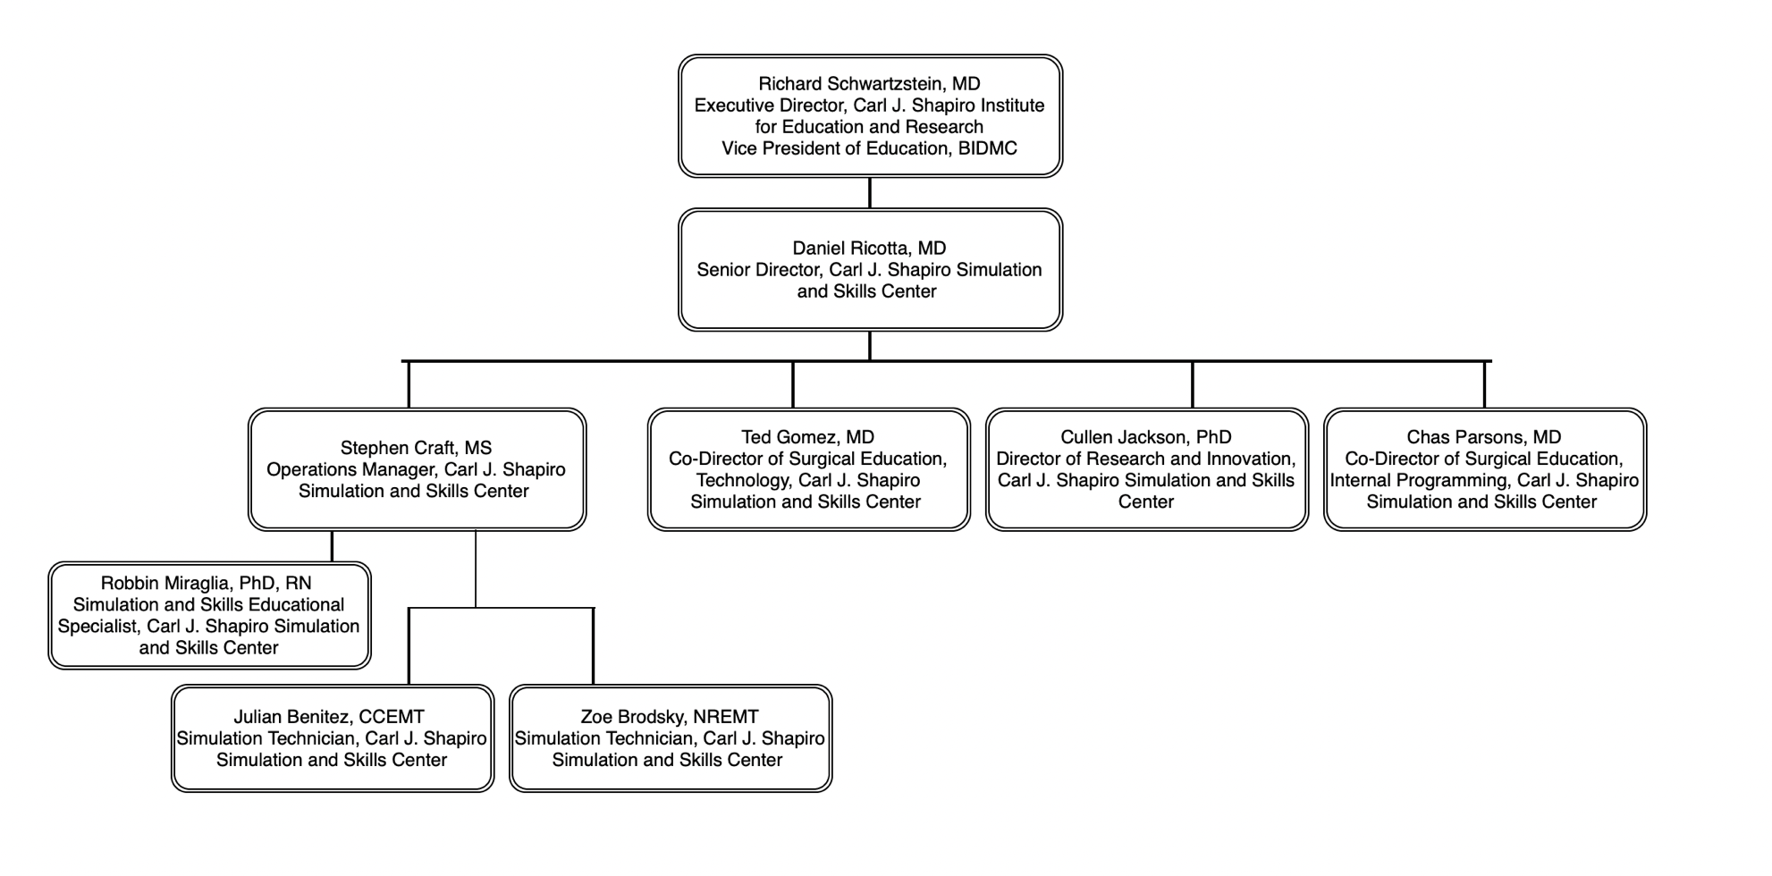

**SASC Advisory Board**

The SASC Advisory Board exists to provide expertise and guidance for the SASC staff, and assures accountability and governance to BIDMC policies. The SASC Advisory Board shall meet at least once per year. The meeting shall be organized by the SASC Operations Manager, who shall also keep record of current advisory board members.

**Floor Plan**

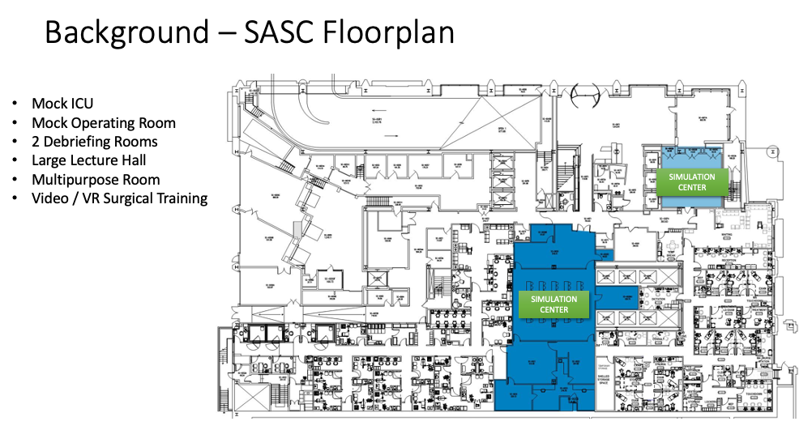

**Decision Making**

Day-to-day decisions are made within the SASC along the authority lines described in the organizational chart. The team defers to each other when guidance or assistance is needed based on each person’s expertise. The team shall meet on a regular basis to assure all employees are working towards the same goals and priorities

**Required disclaimers**

The simulation and skills center staff reserves the right to cancel any event or course at any time. The reason for this policy is due to the needs of the BIDMC during emergency room or staffing issues, weather related issues, or any other multitude of issues that can arise that impact BIDMC. Furthermore, a course that is not considered to meet the highest educational quality or standards, or does not further the education or knowledge of the participants shall be cancelled. As much notice as possible of a cancellation or the possibility of cancelation will be given to the course instructors and their cohorts.

**Conducting Research in the SASC**

A priority of the SASC is conducting research that aligns with the missions of BIDMC and the Shapiro Institute. Any activity exploratory in nature, or involves the collecting or sharing data (including patient specific data), must be reviewed by the IRB and have an IRB designation prior to the initiation of the activity. Requests to conduct research and questions about this process shall be submitted to Robbin Miraglia at [*rmiragli@bidmc.harvard.edu*](mailto:rmiragli@bidmc.harvard.edu)*.*

**3D Printing**

The SASC has a Formlabs Form 3BL medical-grade 3D printer available for use. 3D design services are available, depending on the complexity of the project and availability of SASC staff. The Form 3BL printer can replicate various materials, spanning from soft tissue to bone, allowing for the creation of highly realistic and anatomically accurate models. The SASC aims to collaborate with different departments within the hospital to leverage its 3D printing capabilities for the production of both patient-specific models and essential medical supplies. To schedule a demo or have a conversation to determine whether the 3D printing solutions offered by the SASC are a good fit, please contact the SASC by emailing [SASC-Scheduling@bidmc.harvard.edu](mailto:SASC-Scheduling@bidmc.harvard.edu)

For patient-specific 3D printing, it is required for to have a brief meeting with SASC staff to assure both parties understand both the goals of the project and capabilities of both SASC staff and technology. For any 3D printing project involving human subjects, the project must be IRB approved.

**Video Recording in the SASC**

Many activities at the Simulation and Skills Center (SASC) are video-recorded and/or photographed for academic and research purposes. The videos are securely stored in our SimCapture cloud storage account. The SASC protects the confidentiality of its employees, instructors, and learners. Instructors and learners will sign in to the SASC using a QR code which is linked to a survey. On this survey instructors and learners have the option to consent to videos of their simulation session being included in the data repository, or requesting their video not be included in the data repository. Any use of the video outside of the learning purpose is strictly prohibited.

**Brand Usage Policy**

The name Carl J. Shapiro Simulation and Skills Center shall be acknowledged in all course materials, videos, audio recordings, electronic recordings and publications to which the Carl J Shapiro Simulation and Skills Center was a part of developing. This includes even minimal participation by the center. Permission to use the Carl J Shapiro Simulation and Skills Center name shall be presented to the director of the Simulation and Skills center. This should be done during the presentation of the course materials to the simulation curriculum committee so that all of the stakeholders involved the Center can review and provide feedback, if necessary. This is to ensure the highest quality medical education offerings carry and acknowledge the name of the Carl J. Shapiro Simulation and Skills Center. Please see ADM-52A, Marketing, Logo Usage, Website policies.

**Contact Information**

* Mailing Address: Carl J. Shapiro Simulation & Skills Center Ground Floor #SCG20 330 Brookline Avenue Boston, MA 02215.
* Phone: 617-667-5117
* Email: [SASC-Scheduling@BIDMC.Harvard.edu](mailto:SASC-Scheduling@BIDMC.Harvard.edu)

**Hours of Operation**

The hours of operation for the Carl J. Shapiro Simulation and skills Center are **business weekdays 7:00 AM-5:00 PM**.

The simulation center may be closed at times during normal business hours due to operational commitments, weather related issues, and at the discretion of the director of the SASC. The simulation center may be operational at any time a staff member is present which may include times that are outside of normal business hours. The simulation and skills center front skills arcade are open 24/7 to any physician with a BIDMC badge seeking to use the pc work station or any of the FLS or minimally invasive surgery task practice stations. The front skills arcade may be closed to general usage by SASC staff during FLS/FES/Fuse testing times to ensure privacy and proper environment for any participant during and exam. Any request for the usage of the simulation and skills center during normal business hours and during non-business hours must be made via email addressed to [SASC-Scheduling@bidmc.harvard.edu](mailto:SASC-Scheduling@bidmc.harvard.edu).

**Overtime**

Requests to use the SASC outside of normal business hours may result in an additional fee or be subject to additional restrictions for space and equipment. BIDMC employees working overtime will follow the procedures established by BIDMC for accounting of additional time worked.

1. Scheduling Courses

**Calendar**

All scheduled classes shall be added to the SimCapure calendar found at <https://bidmc.simcapture.com/calendar>.

This calendar should be referenced by both SASC staff, and instructors. All classes, meetings, and simulation related events should be recorded on this calendar. Request for access to this calendar should be submitted via email to SASC-Scheduling@bidmc.harvard.edu.

**Rolling Scheduling**

In 2023 the SASC transitioned to rolling scheduling. Instructors and administrators can request and reserve space in the SASC for their classes by completing form linked here: <https://www.shapiroinstitute.org/request-simspace>.

Within two business days SASC staff shall communicate whether the requests submitted via the above linked form can be accommodated. Requests for space shall not be considered reservations until confirmed by SASC staff.

The SASC Operations Manager shall send out requests for scheduling to all class points of contact at least twice per year to serve as a reminder for each department to reserve time and space in the SASC.

SASC staff will do the best to honor all SASC reservations, but must reserve the right to reschedule classes if necessary. Any questions related to scheduling can be submitted via email to SASC-Scheduling@bidmc.harvard.edu

**Outreach for Scheduled Courses**

The goal of reaching out to departments/instructors before their class takes place is to improve efficiency of the simulation center, reduce downtime, and assure SASC staff are aligned with instructors as to what learning objectives are, and what the curriculum will look like.

Outreach for scheduled courses should occur at least one week before a class takes place, but not more than a month in advance. This communication shall be via email, and [SASC-Scheduling@bidmc.harvard.edu](mailto:SASC-Scheduling@bidmc.harvard.edu) shall be copied on the email. A sample of an outreach email can be found below.

*Good morning!*

*I’m writing to confirm your class (class name)****on (date) from (time).*** *In your response, please provide the approximate number of learners and instructors.*

*We have the following spaces reserved for this class:****List spaces reserved***

*If there is a research component for this class, or you are interested in adding a research or data component to this class, please include that in your response to this email.*

*If you have not already done so, please provide SASC staff with any class materials, an agenda outlining time spent on simulations, and equipment needed at least one week prior to the course. This can be done by emailing*[*SASC-Scheduling@BIDMC.Harvard.edu*](mailto:SASC-Scheduling@BIDMC.Harvard.edu)*.*

*If you have previously shared course documents, either as an attachment or through a link, please be sure that you have provided access from the original document in outlook or teams.*

*If you have questions about the standardized scenario template, please reach out to Robbin Miraglia,*[*rmiragli@bidmc.harvard.edu*](mailto:rmiragli@bidmc.harvard.edu)

*We look forward to seeing you soon!*

*The SASC Team*

**Approval Process for New Courses**

New users or current users requesting new simulation courses in the SASC are required to meet with the SASC staff to get their course and exercises approved. The meeting shall be used to determine several factors, including but not limited to:

* Does the course align with BIDMC and SASC mission?
* What resources are needed to run the simulation activity? (Equipment, staffing, space, funding)
* Is simulation needed to accomplish the learning objectives of the course?

Once it’s determined that a class is appropriate for use of the SASC, the simulation center staff shall determine the classes priority level, and what openings we have to fit the class in. After this, the instructor shall work with SASC staff to determine a date and time to schedule the class.

Once a proposed simulation course has been approved by the simulation committee the following set up materials will be required:

* A course outline and exercise descriptions using the SASC exercise templates.
* A simulation box with required disposables unless they are too large or numerous. A picture of the materials will be placed in the box along with a list of the required materials provided by the course directors. A list of equipment provided by the simulation center should also be placed in the box.
* Pictures of each station fully set up.

**Class Prioritization**

Prioritization of classes and events that occur in the SASC are based on the level of educational importance as determined by the stakeholders involved in the governance of the SASC. Scheduling conflicts will also be handled by the stakeholders of the SASC present based upon the above criteria. All reasonable efforts will be made to prevent such conflicts or to mitigate the effects of any conflicts. If any of the above cannot be resolved by the staff present at the time the issue’s/conflicts will be advanced to the following in the following order until resolved; operations manager, co-director, director, and then the VP of the Medical Education.

**Class Cancellations**

The SASC requests at least 48 hours’ notice for cancelling classes or events. In the event a class is cancelled, SASC staff may reach out to other departments to schedule classes or events for that timeslot. Once a requester submits a cancellation request, they should not assume they could re-book the same timeslot if needed.

If the necessary materials for a class are not provided by the department that booked the course at least one week before the scheduled start date, SASC staff reserves the right to cancel the class. Required materials include but are not limited to instructors, class roster (if course has a participant requirement), a completed simulation scenario template, and simulated medical supplies. In the event of cancellation due to insufficient materials, SASC staff will notify the class administrator and/or instructor(s).

**Prioritization of Resources (Scheduling Disputes)**

The SASC makes every effort to accommodate all scheduling requests. Due to limited staffing and equipment resources, there may be times when classes are unable to be scheduled, or need to be rescheduled to meet the overall needs of BIDMC.

Once a class is on the schedule, their timeslot must be adhered to. On the day of a class, SASC staff has the authority to enforce the calendar’s schedule, and if needed, reschedule or cancel a class that does not adhere to the original schedule. For example, if a class that is scheduled for 8:00-10:00 shows up at 9:00 and is under the impression their timeslot is 9:00-11:00, SASC staff has the authority to reschedule or cancel their class due to lack of staffing or equipment resources.

**Outside Learners and Rental Fees**

The Simulation and Skills Center (SASC) is available as a venue for courses involving outside learners. If there is at least one learner from outside of BIDMC in a class, the class shall be subject to a facility fee. Upon scheduling a class with outside learners, the SASC Operations Manager shall request billing information from the person who requested the class. If the person who requested the class is unable to provide billing information 14 days before the class is scheduled, the class may be cancelled. Upon completion of the class, a bill will be sent to the address provided by the person who requested the class.

We also have a number of simulators that are available for rental. Below is contact information and a listing of our current rental fees and services that we offer. These rental services are separate and in addition to regularly run BIDMC courses.

To make arrangements please contact the Simulation and Skills Center at:

Email: SASC-Scheduling@BIDMC.HARVARD.EDU

Phone: 617-667-5117

|  |  |  |
| --- | --- | --- |
|  | **BIDMC Learners[1]1** | **Outside Learners** |
| Skills Access | Waived | $100 |
| Videotaped Session | Waived | $250 |
| Facility Fee* | Waived | $ 3,000 |

\**HMS learners shall be considered BIDMC learners and not charged a facility fee*

Events scheduled outside of the normal hours of operation (M-F 7:00-5:00) will incur an additional $150per hour per staff member.

**Skills Access**: Access to the simulation center for a day, plus consumables

**Simulation Session**: Use of either the ICU or OR simulation space, and the debrief room for simulations

**Videotaped Session:** Use of the debrief room and video/audio capture

**Lecture Hall**: Use of the large lecture room and equipment

**Equipment Rentals:** The SASC can provide a simulator and tissues to BIDMC learners, but outside learners must purchase their own tissues from the simulation center. The available simulators and their prices are listed below:

|  |  |  |
| --- | --- | --- |
| **Equipment** | **BIDMC Learners** | **Outside Learners (per day)** |
| Blue Phantom Central Venous Access Head and Torso | Waived | $100 |
| Blue Phantom Nerve Block Simulator | Waived | $100 |
| Simulab Central Line Man | Waived | $100 |
| Simulab Femoral Line Man | Waived | $100 |
| Life/form Cricothyroidotomy Simulator | Waived | $100 |
| Laerdal Airway Management Trainer | Waived | $100 |
| Arterial Arm Simulator | Waived | $50 |
| Veinous Arm Simulator | Waived | $50 |
| Kyoto Kagaku Lumbar Puncture Simulator | Waived | $100 |
| VATA Phlebotomy Skills Trainers | Waived | $200 |

**Outside Learners Cancelation Policy**

A deposit of $1,000 is required one month before a class takes place. The balance will be invoiced after the delivery of the class. Upon requesting a class, a name and address shall be provided to send the invoice. Class dates and times, and name and address of the class requester shall be provided to a Shapiro Institute Financial Analyst, who will send the invoice.

Classes that include outside learners can be cancelled up to 14 days in advance with no penalty.

If a class with outside learners is cancelled between 7-14 days in advance, there will be a $1,000 facility fee.

If a class with outside learners is cancelled less than 7 days in advance, there will be a $1,500 facility fee.

**Tours**

Tour requests should be submitted to [SASC-scheduling@bidmc.harvard.edu](mailto:SASC-scheduling@bidmc.harvard.edu). SASC staff will accommodate tours if time, and class schedule allows. Tours outside of the hours of 7:00-5:00 generally will not be given, but exceptions may be made.

1. Equipment

**Simulation Equipment Maintenance and Repair**

Maintenance and Repair, remote or on site, shall be scheduled during times when there are no classes scheduled. This will minimize the chance of this maintenance negatively impacting classes. After maintenance and repair is completed, the impacted simulation systems should be tested to assure they are fully operational. Any maintenance or repair shall be logged in the *Tasks* section of Microsoft Teams.

**Acquisition of Equipment**

When supplies arrive as the SASC, simulation educators ensure they are labeled “not for patient use” if applicable. Items should also be added to inventory upon arrival. SASC staff is responsible for assuring all supplies are available for each course, and should confirm this approximately three weeks prior to a course. If supplies need to be purchased, the SASC staff will facilitate this.

When ordering larger equipment or services, quotes from vendors should be solicited. When it is confirmed that there is both a need and budget for equipment or services SASC staff will submit a purchase order for equipment or services. A BIDMC Center for Education financial analyst should be consulted if there are any questions related to this process, currently this person is Diana Wang.

If equipment or services are from a new vendor, there is required paperwork to be completed in order to execute a purchase order.

**Borrowing Task Trainers from the SASC**

Policy: Task trainers may be borrowed for clinical education purposes by BIDMC clinicians. Use of these trainers must align with institutional policies and the mission of the Simulation and Skills Center.

**Procedure:**

1. **Request and Approval**
2. All task trainer requests must be submitted at least one week in advance of the intended date. The “Request for Resources” can be found on the SASC website or provided by a SASC staff member.
3. Requests must be made via the “Request for Resources” can be found on the SASC website or provided by a SASC staff member.
4. Approval is subject to availability and must be confirmed by authorized SASC staff.

1. **Eligibility**
2. Only BIDMC clinicians (physicians, nurses, allied health professionals, etc.) are eligible to borrow task trainers.
3. Task trainers may not be used off-campus without explicit permission.

1. **Responsibility and Liability**
2. The individual who signs out a task trainer assumes full responsibility for its condition during the lending period.
3. Any loss, theft, or damage (beyond reasonable wear and tear) will result in the borrower being held financially responsible for repair or replacement costs.
4. Task trainers must be returned in clean and functional condition, as received.

1. **Return and Inspection**
2. Trainers must be returned by the agreed date.
3. SASC staff will inspect all returned trainers. Any issues will be documented, and the borrower will be contacted regarding the next steps.

1. **Non-Compliance**
2. Failure to adhere to this policy may result in the denial of future borrowing privileges.

**Equipment Loan/In Situ Use**

Faculty, instructors, and training partners may request to check out specific equipment, simulators, and supplies. Equipment can be loaned out at the discretion of SASC staff. All requests for equipment use should be sent to [SASC-Scheduling@bidmc.harvard.edu](mailto:SASC-Scheduling@bidmc.harvard.edu). Requests can also be made directly to SASC staff members in person or via e-mail.

The following equipment is available for use:

* Blue Phantom Central Venous Access Head and Torso
* Blue Phantom Nerve Block Simulator
* Simulab Central Line Trainer
* Simulab Femoral Line Trainer
* Life/form Cricothyroidotomy Simulator
* Laerdal Airway Management Trainer
* Arterial Arm Simulator
* Veinous Arm Simulator
* VATA IV trainers
* Kyoto Kagaku Lumbar Puncture Simulator

**Inventory**

Inventory shall be performed by a Simulator Technician on an ongoing basis, and be available in the shared drive. Requests to order new equipment shall be submitted to the Operations Manager.

Inventory of Kits and Consumables shall be recorded on the **Kits & Consumables** excel sheet in Microsoft Teams. The goal of this sheet is to track spending, costs, par level, number currently on hand, and expected future use of this equipment. It’s important to designate equipment that is reusable in this document. When classes use consumables Simulation Technicians should keep record on this sheet. If we are below our par level on any supplies, the Simulation Technicians should notify the Operations Manager of the SASC so replacements can be ordered.

1. **SASC Operations**

**Weekly Huddle**

The SASC Operations Manager shall facilitate a weekly huddle no later than Tuesday of each week. All full time SASC staff shall attend if available. The SASC Operations Manager will send out an agenda prior to this meeting. During this meeting the following topics should be addressed:

* Upcoming Schedule, typically covering until the following Friday
* Needs of supplies or consumables
* Any upcoming events
* Needs, questions, or concerns of staff

**Monthly Staff Meeting**

The SASC Operations Manager shall facilitate a monthly staff meeting on the first Friday of each month. All full time SASC staff, directors, and co-directors should attend if available. The SASC Operations Manager will send out an agenda prior to this meeting. During this meeting the following topics should be addressed:

* Each person shall update the rest of the staff on their work the past month
* Any upcoming events
* Expansion of SASC offerings
* Assuring the SASC is on track to accomplish short-, medium-, and long-term goals

**Start Up Process**

The SASC Simulation Technicians shall be responsible for daily setup of simulation spaces. Educators are responsible for arriving prior to their course to ensure the setup and available supplies are correct. The SASC staff will start mannequins, laptops, and equipment. If educators are experienced starting mannequins and operating simulation classes, they are permitted to do so.

**Shut Down Process**

It is the Simulator Technician’s responsibility to inform SASC staff when a course is complete. After this has happened, SASC staff member will prepare the room for the next simulation exercise. If another exercise is not planned, a SASC staff member will shut down equipment.

**Class Attendance**

Class attendance is by learners scanning a QR code located at the entry of the Videoconference Room. It is the responsibility of SASC staff to have the QR code displayed in the entrance to the Videoconference Room. Learners should be made aware by instructors that scanning the attendance QR code is required. SASC staff should periodically check the attendance spreadsheet to assure it’s accurately being recorded.

The class sign-in includes a video recording consent. If a learner or instructor wishes the video from the class is not included in our data repository, they can decline consent when signing in to the class using the QR code.

**Embedded Person**

Classes that require an embedded person in a simulation exercise are common in the SASC. When a class requires an embedded person, SASC staff shall agree upon who will play the embedded person role at least one week in advance. This information shall be added to SimCapture in the *Public Notes* section. The embedded person is responsible for familiarizing themselves with the exercise and the instructor’s expectations of the embedded person.

**Session Evaluations**

There are three separate evaluations conducted by the SASC. All surveys can be found in the SASC’s Microsoft 365 account. The surveys are the following:

1. **Yearly Instructor Surveys**
2. **Class-specific Learner Surveys**
3. **Class-specific Instructor/SASC Staff Surveys**

**Yearly Instructor Surveys**

Yearly Instructor Surveys shall be sent via email to instructors who have taught classes in the SASC during the last calendar year. Records shall be kept in the shared drive of the Staff Microsoft 365 account, and added to the institute shared drive.

**Class-specific Learner Surveys**

Class-specific Learner Surveys shall be automatically sent out when a learner signs in using the attendance QR code. Records shall be kept in the shared drive of the SASC Microsoft 365 account, and added to the institute shared drive.

**Class-specific Instructor/SASC Staff Evaluations**

In an effort for instructors and SASC to exchange feedback, SASC staff shall send evaluations to instructors to complete. These evaluations are sent out at the degression of SASC staff, or at the request of instructors. The goal of these evaluations is for SASC staff to collaborate with instructors on how to improve classes that occur in the SASC. Both positive and constructive feedback are encouraged by both parties.

**Audio Visual Systems**

Audio visual systems shall be checked daily during the start-up process. Any audio-visual issues shall be documented, and be resolved by the SASC staff. For issues that cannot be resolved by SASC staff, AV technical vendors are listed below. The SASC Operations manager shall schedule all audio-visual repair work.

Mike Langolis: MLangloi@BIDMC.Harvard.edu

Jeff Gerow: [Gerow.Jeff@Gmail.com](mailto:Gerow.Jeff@Gmail.com)

**Simulation and Skills Center (SASC) Visiting Student Policy**

**Purpose**

This policy outlines the guidelines and requirements for visiting students who wish to utilize the SASC for educational and training purposes.

**Welcome**

The SASC warmly welcomes visiting students from various educational institutions. We are committed to providing a supportive and enriching environment to help students achieve their educational goals through observation and hands-on simulation training.

**Point of Contact**

All visiting students must have a designated point of contact within the department who arranged their visit to the SASC. This point of contact will be responsible for coordinating the student’s schedule, ensuring compliance with BIDMC policies, and serving as a liaison between the student and SASC staff.

**HIPAA Training**

In compliance with federal regulations, all visiting students must complete Health Insurance Portability and Accountability Act (HIPAA) training prior to their arrival at the SASC. Proof of HIPAA training completion must be submitted to the SASC Operations Manager as part of the onboarding process.

**Commitment Requirement**

To ensure that educational objectives can be fully realized, visiting students must commit at least one month of participation in SASC activities. This duration allows for adequate exposure to simulation scenarios, practice time, and the opportunity to receive comprehensive feedback from instructors and staff.

**Procedures**

Application and Approval

1. Interested students must fill out a Microsoft Form provided by the SASC Operations Manager.
2. The department’s point of contact must submit a list of the student’s intended schedule and learning objectives.
3. After review by the Simulation and Skill Center staff, a decision to approve or deny the visiting student shall be made and communicated to the department’s point of contact who submitted the student’s intended schedule and learning objectives

Onboarding

1. Upon approval, students will undergo an onboarding process that includes orientation to the SASC facilities and review of safety protocols.
2. The SASC Operations manager must receive proof of HIPAA training completion.

Training and Participation

1. Students will be integrated into the SASC schedule and must adhere to SASC guidelines and protocols.
2. Participation in simulations and classes is based on instructor approval.

Compliance and Conduct

1. Students must adhere to all BIDMC and SASC policies.
2. Any breach of policy or unprofessional conduct may result in termination of the student’s access to the SASC.

Feedback and Evaluation

1. Regular feedback sessions will be conducted to assess the student’s progress and ensure that educational goals are being met.
2. Students are encouraged to provide feedback on their experience to help improve SASC training programs for students.
3. The SASC reserves the right to end the relationship with a visiting student at any time. This decision may be based on non-compliance with MSC policies, unprofessional conduct, or any other reasons deemed appropriate by BIDMC or SASC administration.

Conclusion

The SASC is dedicated to fostering a productive learning environment for visiting students. By adhering to this policy, we aim to provide a structured and beneficial experience that contributes to the students’ academic and professional development.

For any questions, please contact the SASC Operations Manager Stephen Craft at SCraft@BIDMC.Harvard.edu.

**Sustainability in the SASC**

Whenever possible and safe, the SASC will prioritize financial and environmental sustainability by reusing supplies, and donation of equipment provided by other departments within the hospital.

Before ordering new kits or supplies from the hospital through Workday, SASC staff should check with Andrew (AJ) Masters at [AMasters@bidmc.harvard.edu](mailto:AMasters@bidmc.harvard.edu)

to see if the hospital has any expired equipment that could be used by the SASC.

If there are questions about disposal or procurement of recycled items, SASC staff shall reach out to the Environmental Sustainability department by emailing [Sustainability@bidmc.harvard.edu](mailto:Sustainability@bidmc.harvard.edu).

The SASC is part of the Medical Supply Donation program at BIDMC. Details about the program can be found below. Questions about the program can be sent to Avery Palardy at [apalardy@bidmc.harvard.edu](mailto:apalardy@bidmc.harvard.edu).



**Visitor Parking**

The SASC does not supply parking passes. When there are visitors coming to the SASC, direct them to park in the Shapiro Garage and access the Simulation Center via the Binney Street entrance to BIDMC’s East Campus.

**Guest Computer and Internet Access**

Guests should use the wireless network ***bidmcguest*** to access the internet on their own devices. Guests who have a BIDMC login are welcome to use the computer workstations in the Skills Arcade.

**Printing**

The workstations SASC users have access to in the Skills Arcade are connected to the printer in the Skills Arcade. Users are welcome to use this printer for documents 50 pages or less. **This printer does not print in color**. SASC staff can approve and print color documents upon request.

1. 1 Courses that require specialized equipment, rentals, or special supplies may incur a fee. Courses that are grant funded or sponsored may incur a fee.